**ONE WAY PROCESS OF DOWNLOAD THE JAR FILES**

**Step 1:** Open Google Chrome and Type mvnRepository

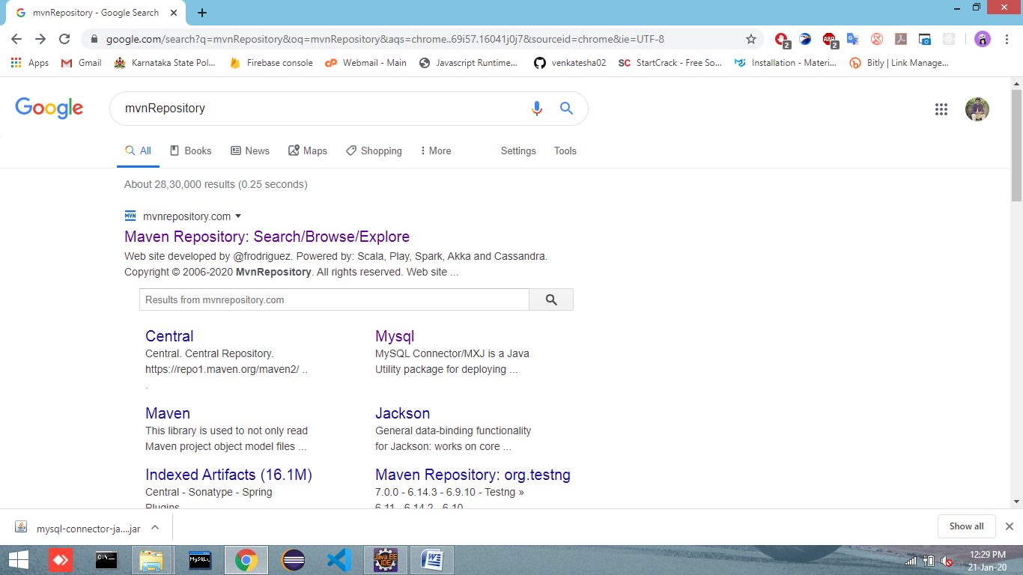

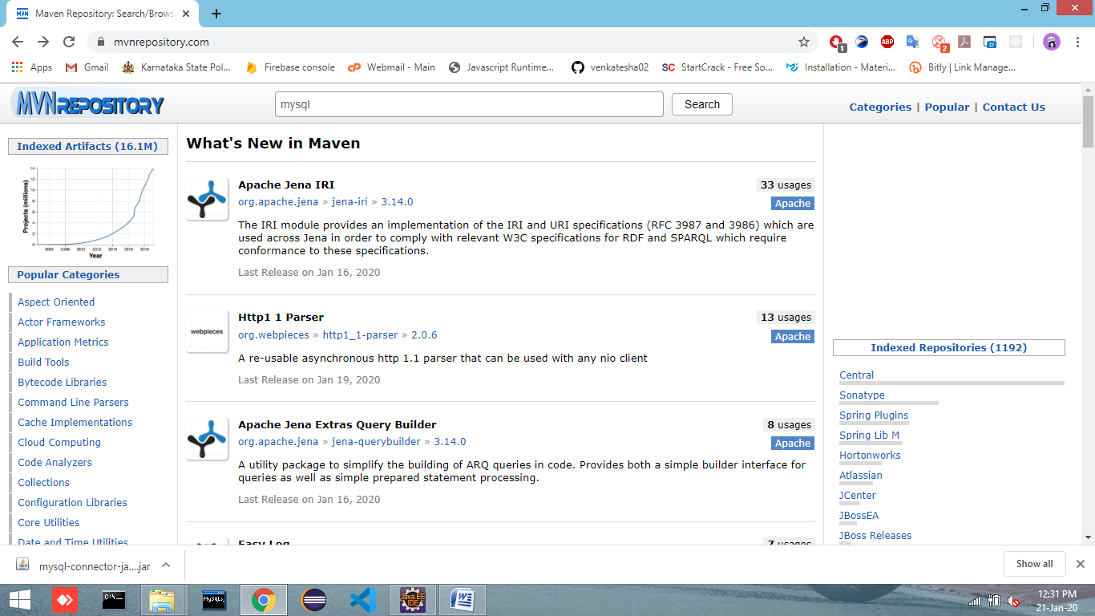**Step 2:** in search bar type mysql then hit Enter

**Step 3:** Select [**MySQL Connector/J**](https://mvnrepository.com/artifact/mysql/mysql-connector-java) and Click on it

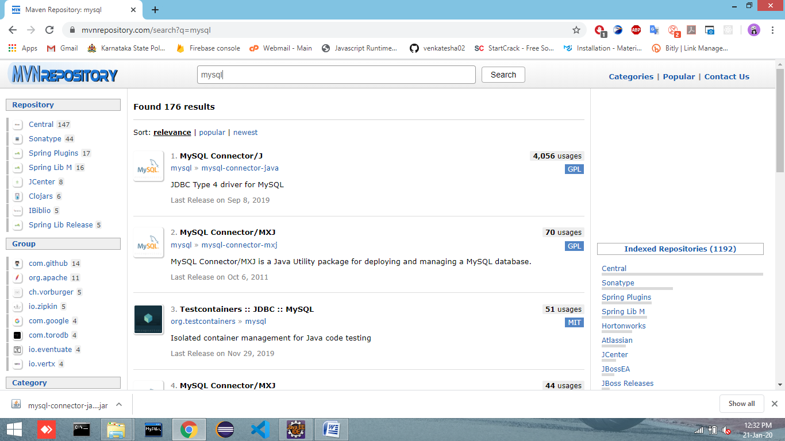

**Step 4:** Select 5.1.47

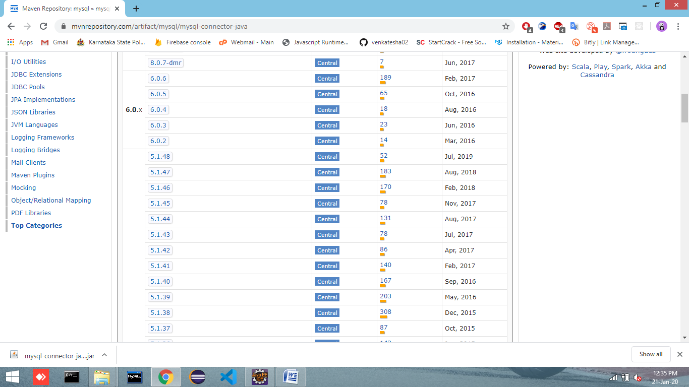

**Step 5:** Download

